Task1:

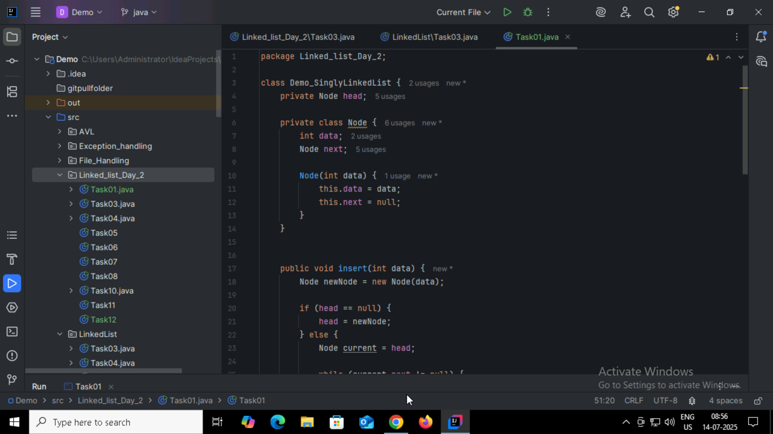

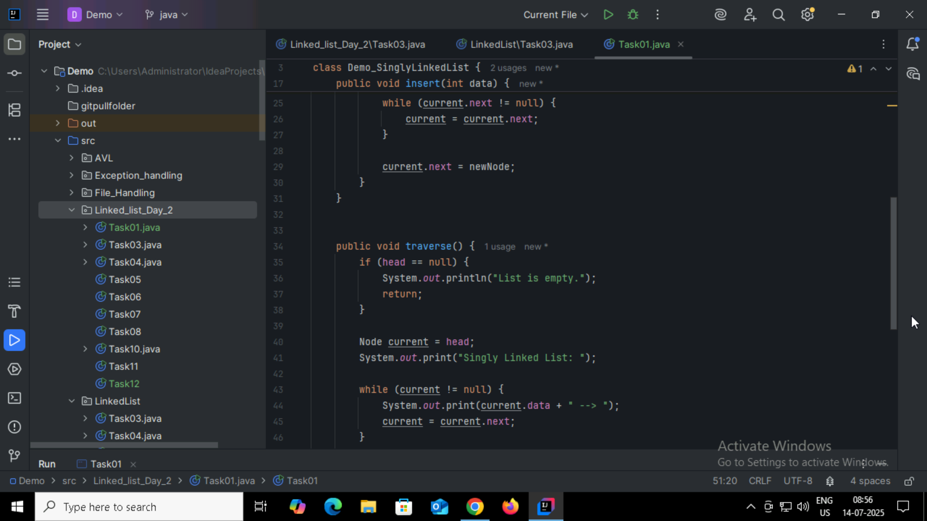

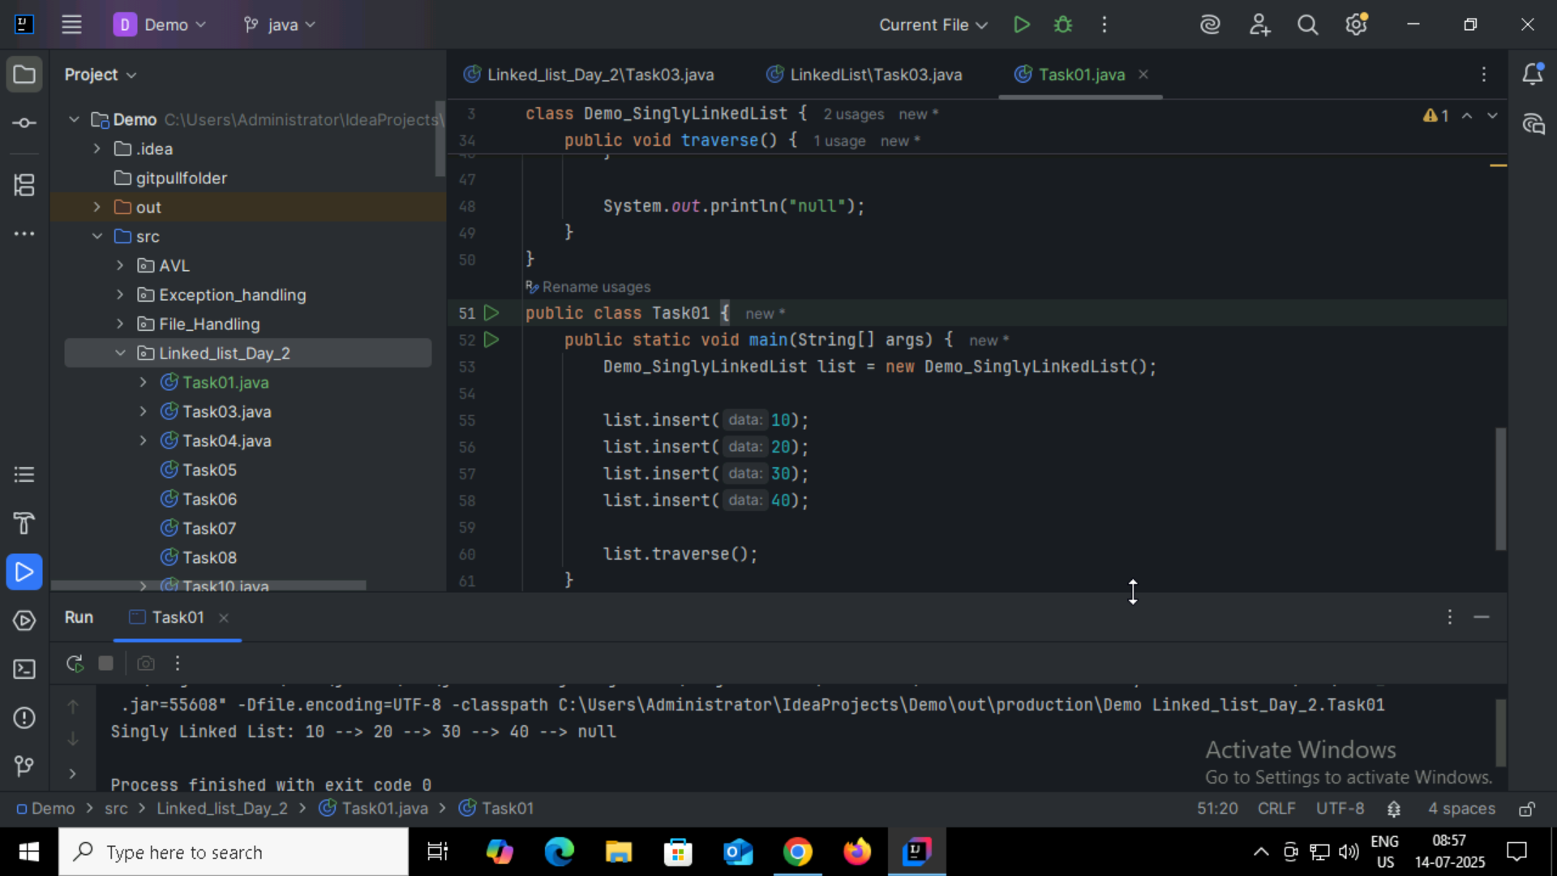

Task2:

What do you mean by traversing?

Traversing a list means visiting each one by one from the start to the end to read data perform operations like print,search,count.

Task3:

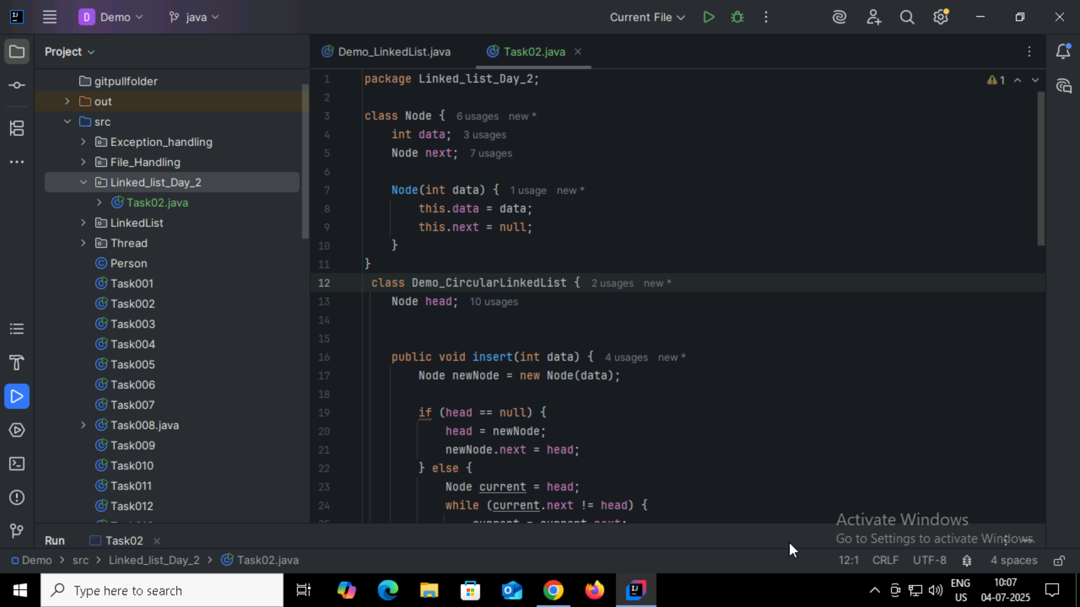

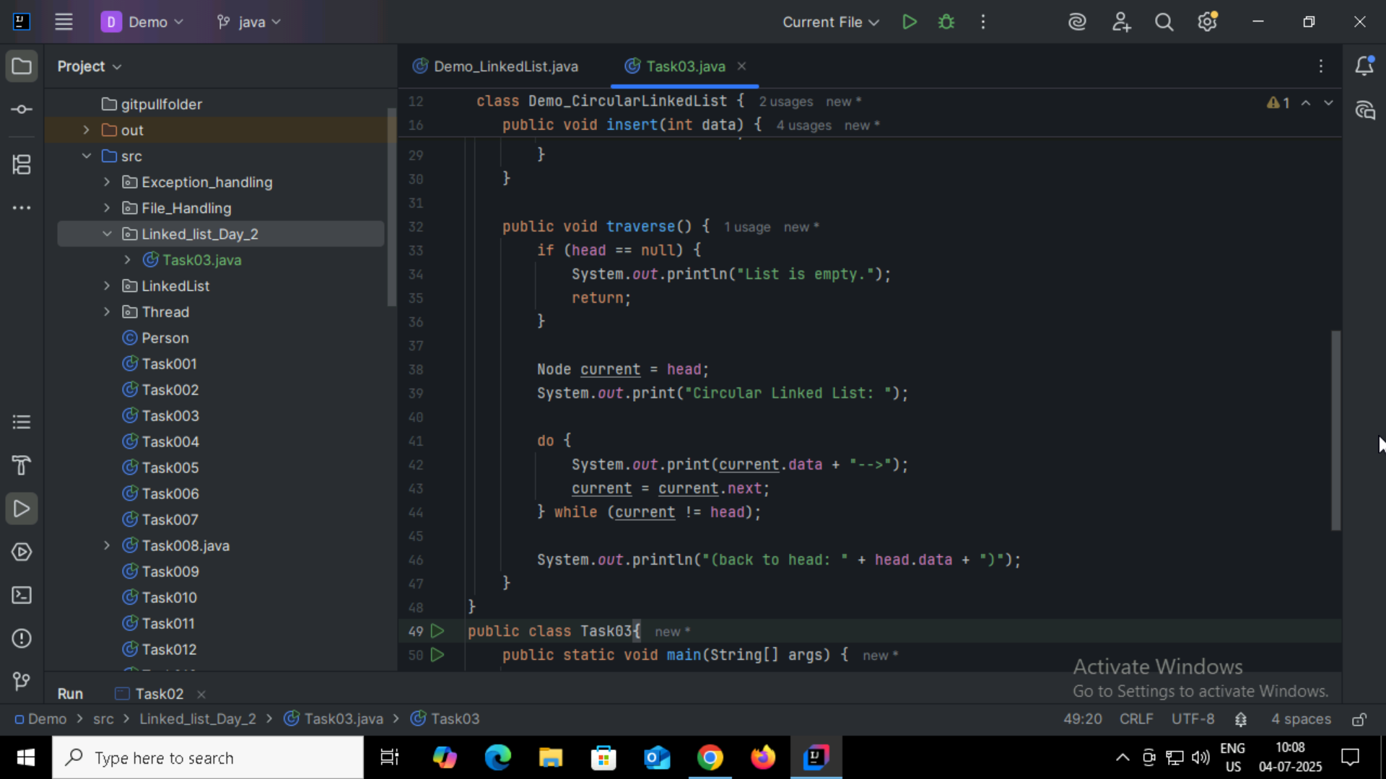

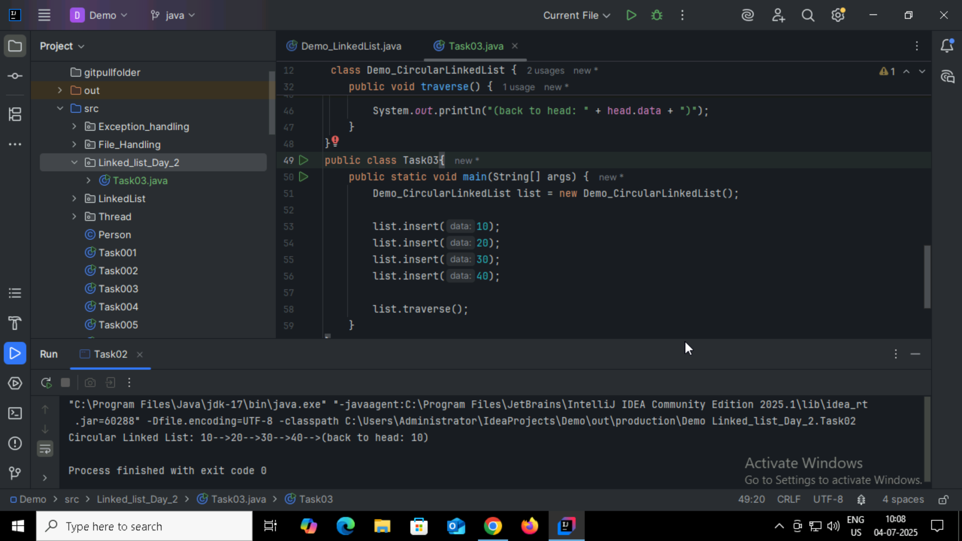

Task4:

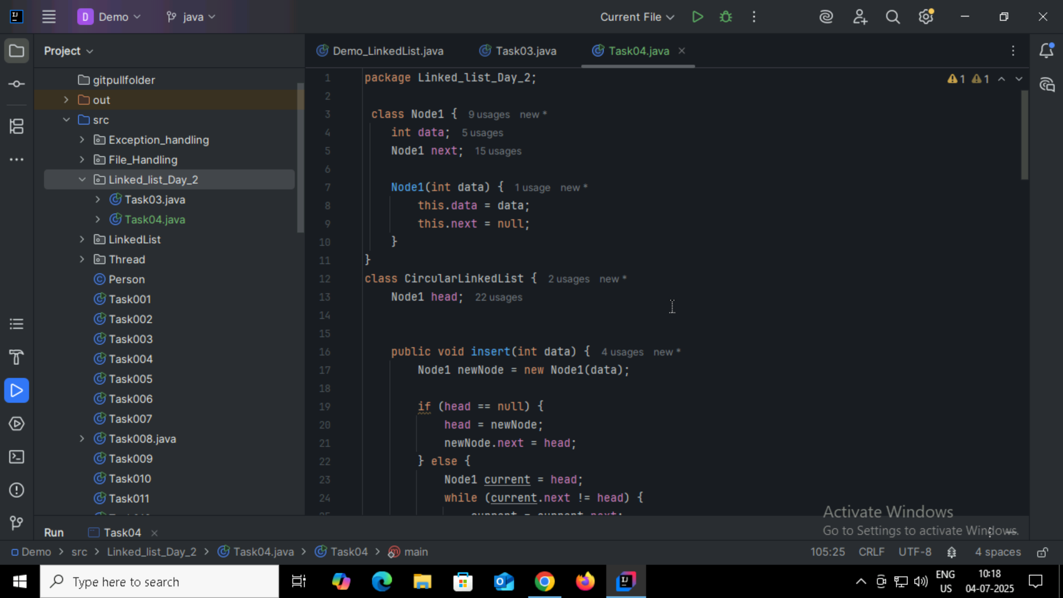

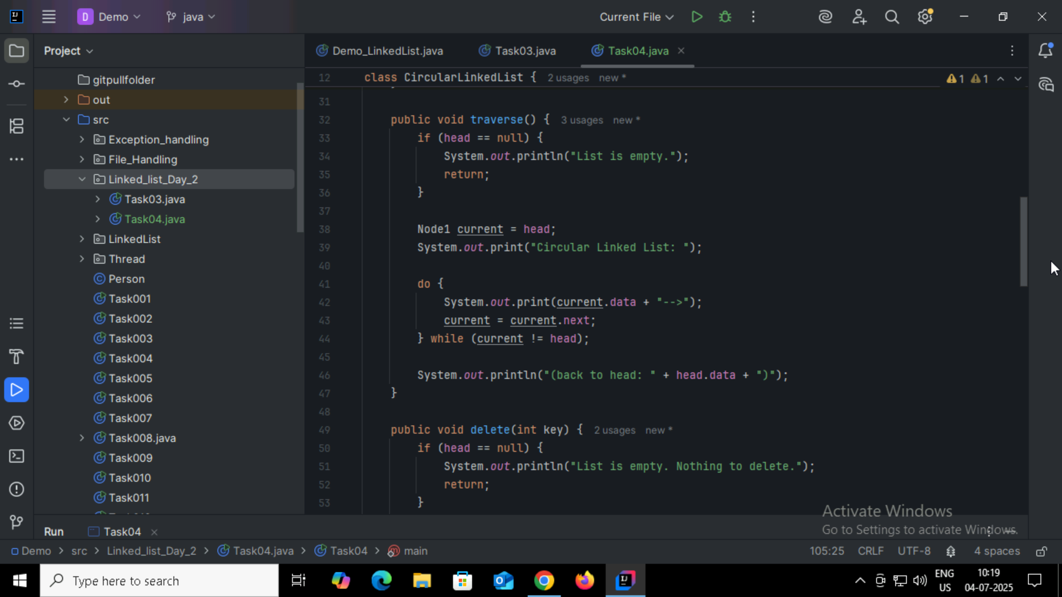

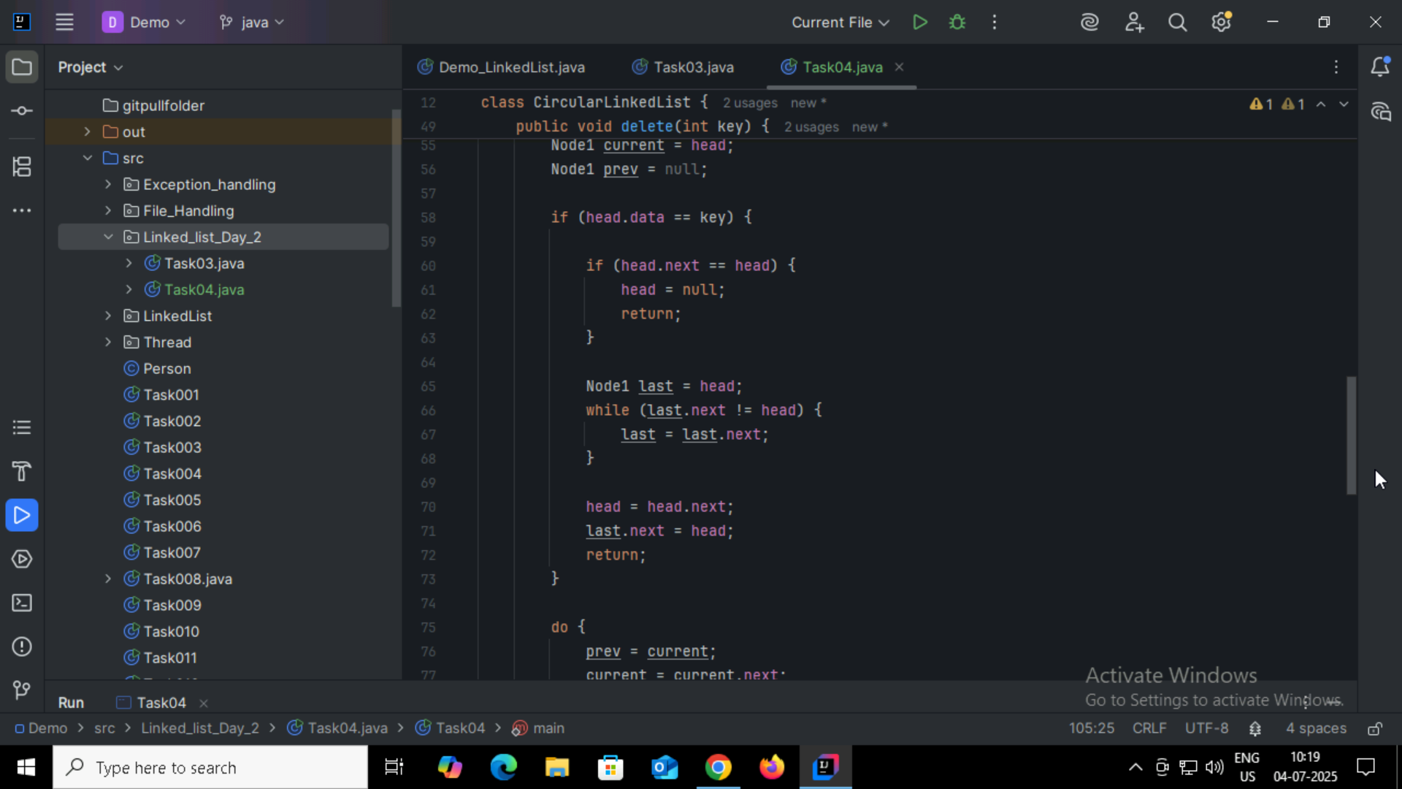

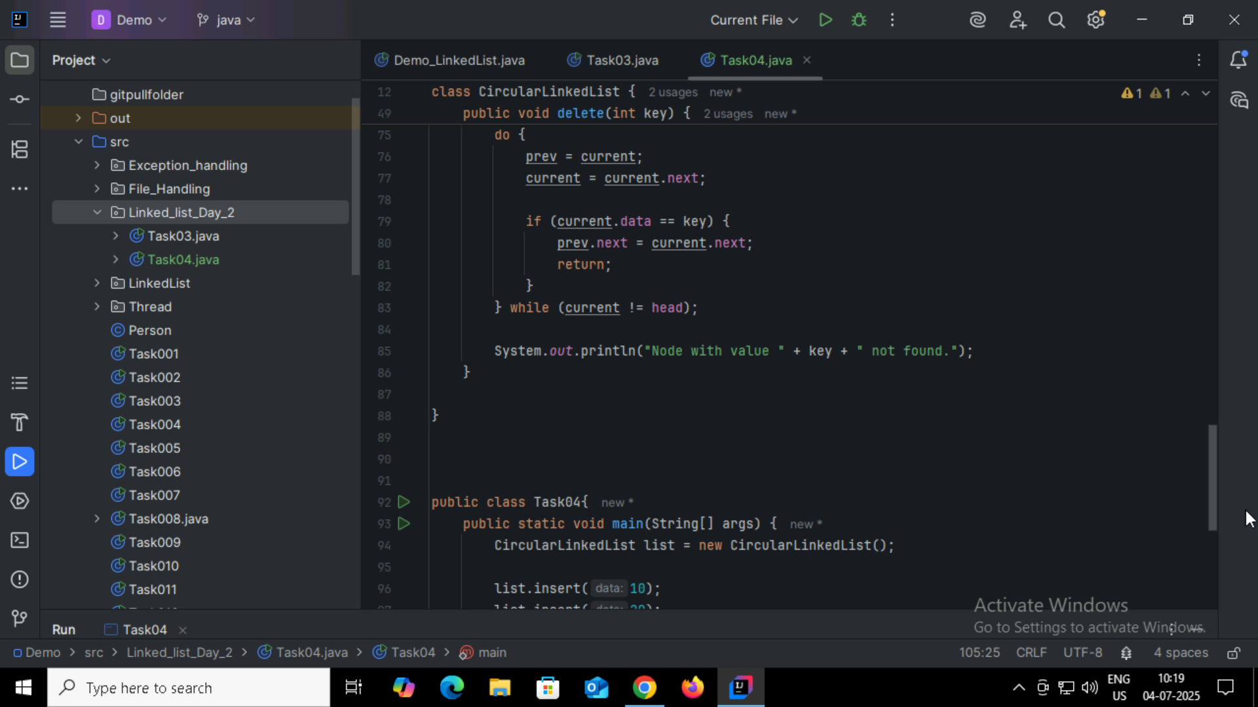

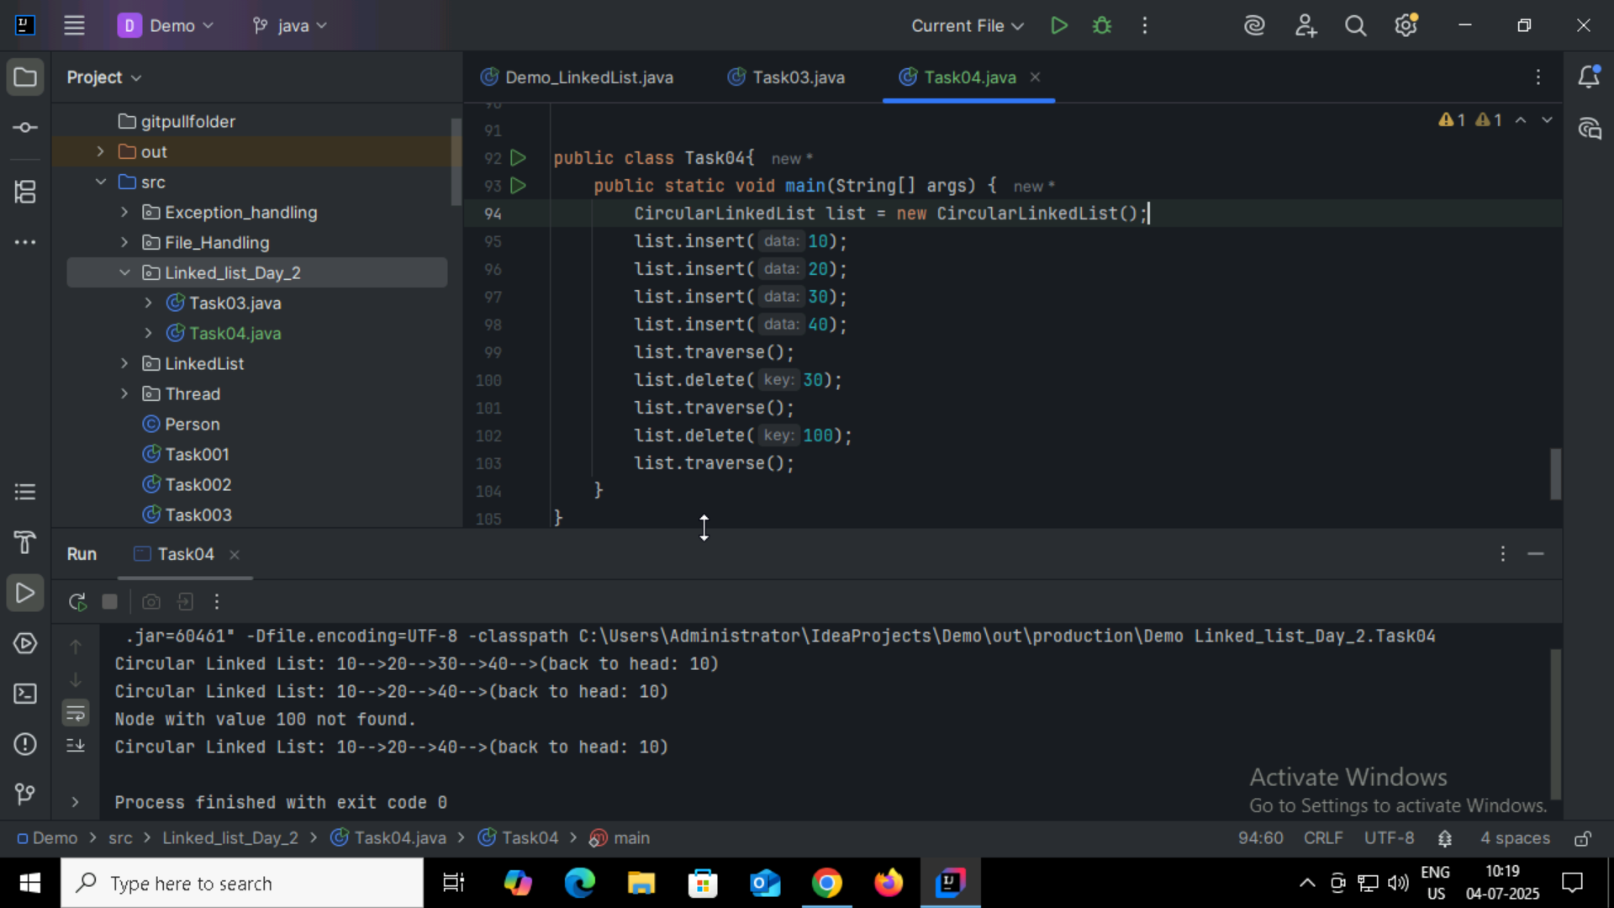

Task05:

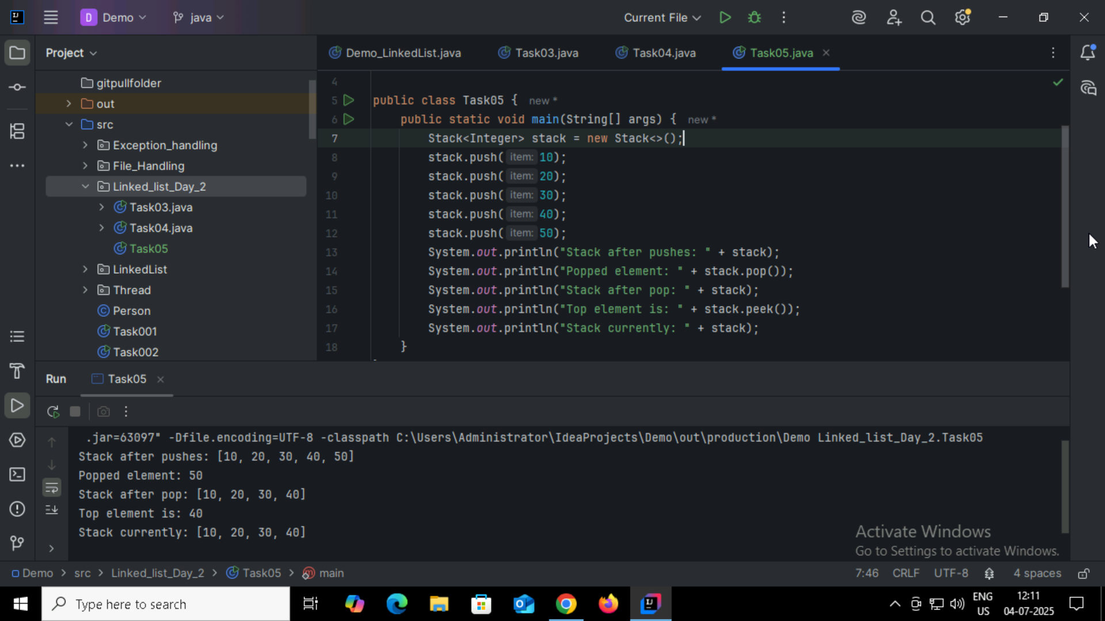

Task06:

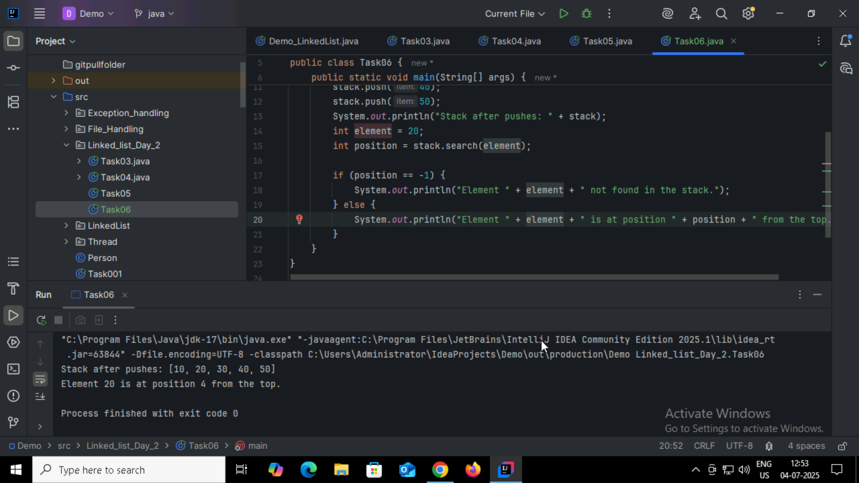

Task07:

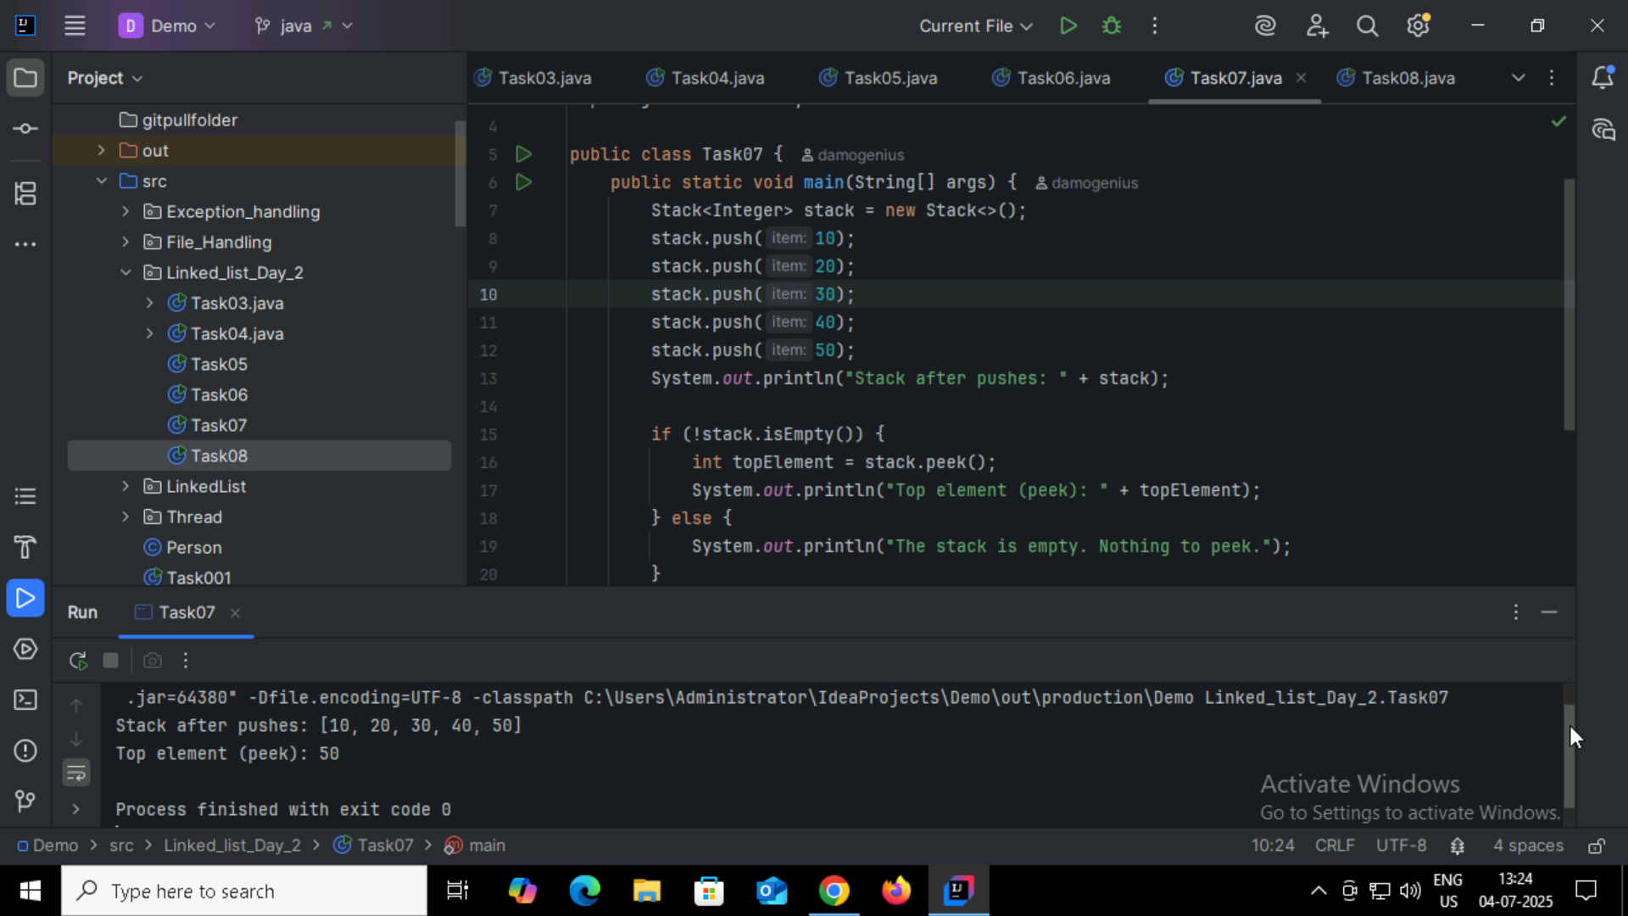

Task08:  
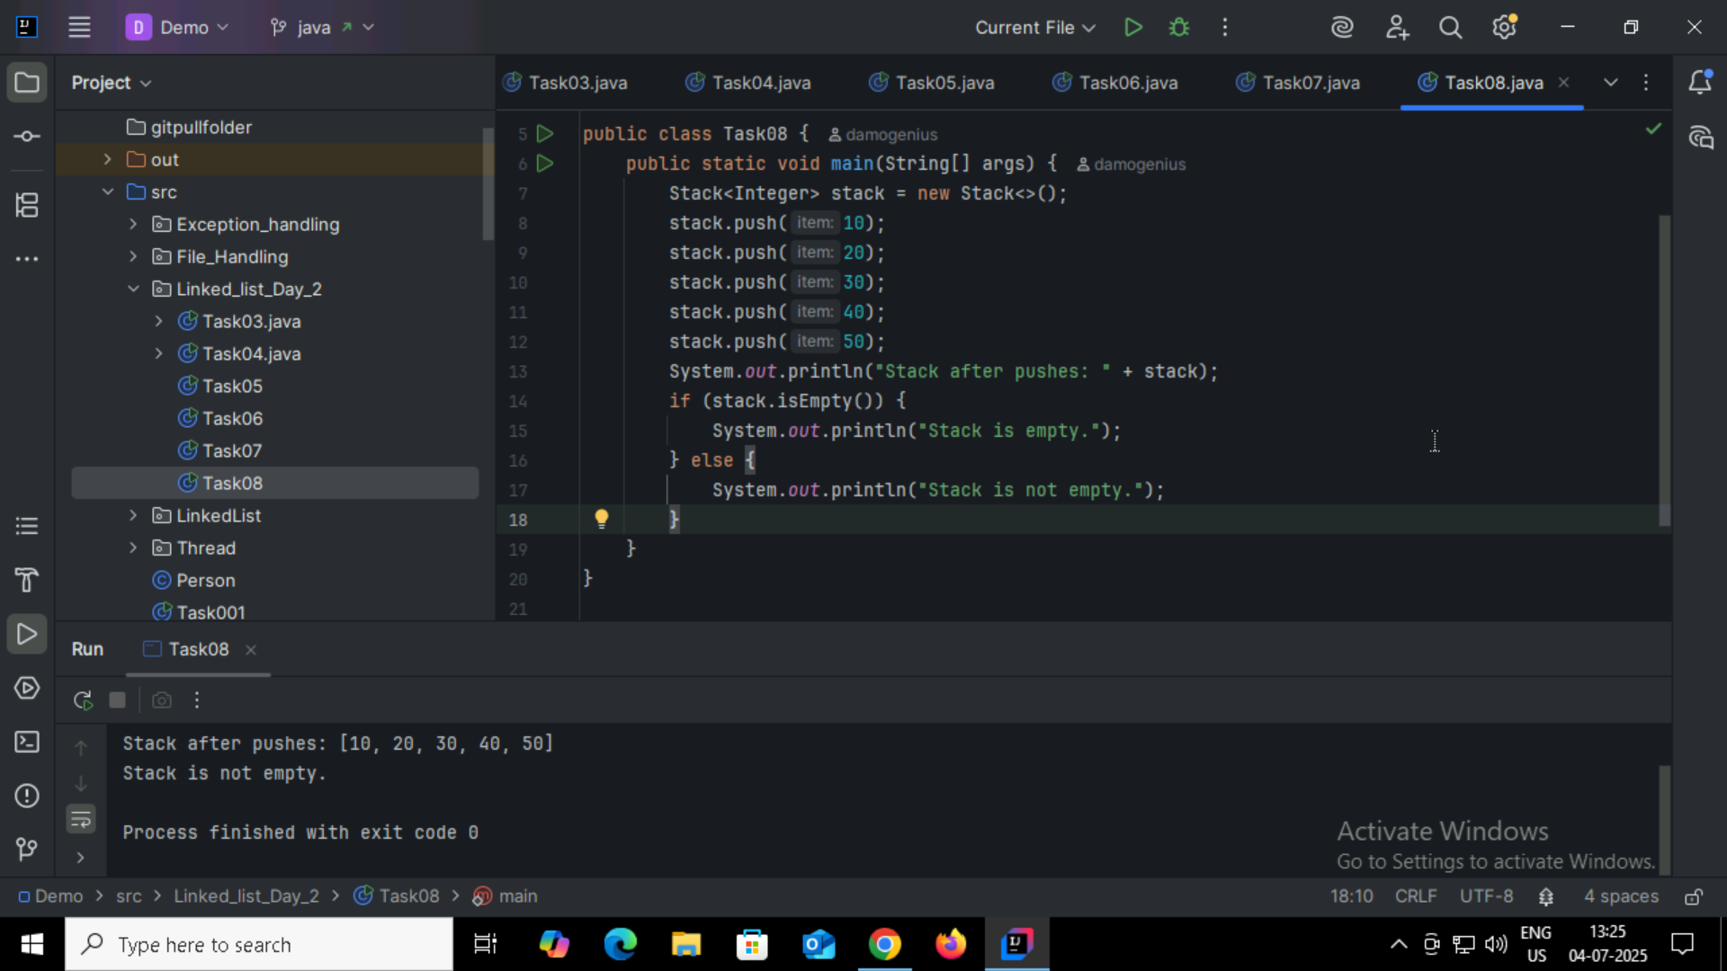

Task09:

* **push(E item)** – Inserts an element onto the top of the stack.
* **pop()** – Removes and returns the top element of the stack.
* **peek()** – Returns the top element without removing it.
* **empty()** – Returns true if the stack is empty.
* **search(Object o)** – Returns the 1-based position of an element from the top; -1 if not found.
* **isEmpty()** – Checks if the stack has no elements (inherited from Vector).
* **size()** – Returns the number of elements in the stack (from Vector).
* **clear()** – Removes all elements from the stack.
* **contains(Object o)** – Checks if the stack contains a specific element.
* **iterator()** – Returns an iterator over the elements in the stack.

Task10:

